**DEPA ASSIGNMENT 2 – SQL QUERIES**

Name: Troy Zhongyi Zhang

Netid: [zhongyiz@uchicago.edu](mailto:zhongyiz@uchicago.edu)

Part B (Individual): Manipulating, Categorizing, Sorting and Grouping & Summarizing Data

Data ( Sakila dataset )

➢ We will use the Sakila database schema which can be found at: http://dev.mysql.com/doc/index-other.html/

➢ Full documentation: http://dev.mysql.com/doc/sakila/en/

**/***********************************************  
** File: Assignment2-PartB.sql  
** Desc: Manipulating, Categorizing, Sorting and Grouping & Summarizing Data**

**\*\* Author: Troy Zhongyi Zhang  
** Date: 07/25/2019  
************************************************/**

**######## QUESTION 1 ######## – { 10 Points }**

**# a) Show the list of databases.**

SHOW DATABASES;

8 row(s) returned

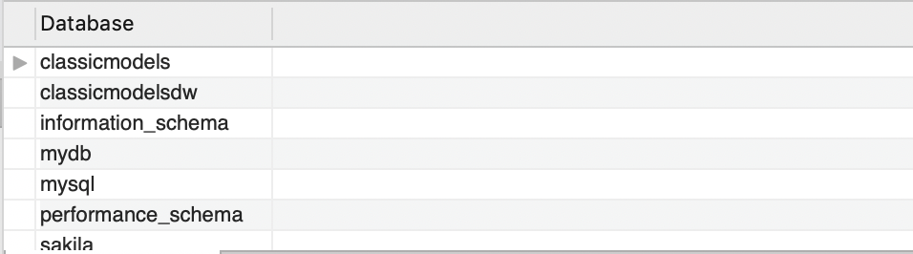

**# b) Select sakila database.**

USE sakila;

0 row(s) affected

**# c) Show all tables in the sakila database.**

SHOW TABLES;

17 row(s) returned

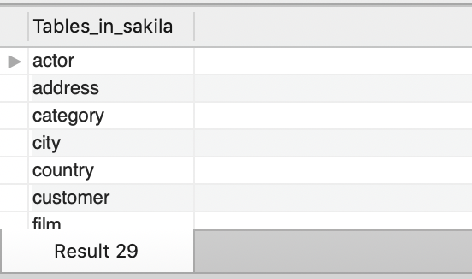

**# d) Show each of the columns along with their data types for the actor table.**

DESCRIBE actor;

4 row(s) returned

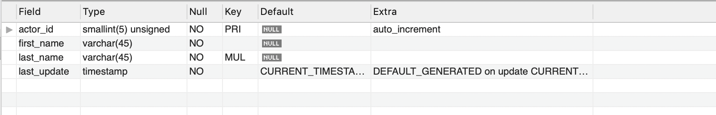

**# e) Show the total number of records in the actor table.**

SELECT COUNT(*) FROM actor;

or

SELECT COUNT(actor_id) AS totalNumberOfActors FROM actor;

1 row(s) returned

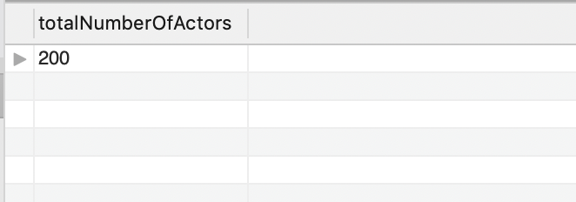

Return 200 actors

**# f) What is the first name and last name of all the actors in the actor table?**

SELECT

first_name, last_name

FROM

actor;

200 row(s) returned

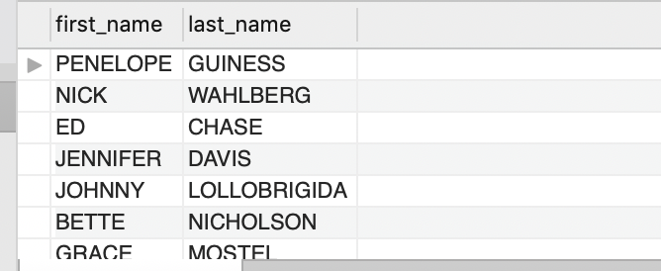

**# g) Insert your first name and middle initial ( in the last name column ) into the actors table.**

INSERT INTO `actor`

(`actor_id`,`first_name`,`last_name`,`last_update`)

VALUES

('201','Troy Zhongyi','Z','2019-07-18');

1 row(s) affected

**# h) Update your middle initial with your last name in the actors table.**

SET SQL_SAFE_UPDATES = 0;

UPDATE actor

SET

last_name = 'Z Zhang'

WHERE

last_name = 'Z';

1 row(s) affected Rows matched: 1 Changed: 1 Warnings: 0

**# i) Delete the record from the actor table where the first name matches your first name.**

DELETE FROM actor

WHERE first_name = 'Troy Zhongyi';

1 row(s) affected

**# j) Create a table payment_type with the following specifications and appropriate data types**

**# Table Name : “Payment_type”**

**# Primary Key: "payment_type_id”**

**# Column: “Type”  
# Insert following rows in to the table:**

**# 1, “Credit Card” ; 2, “Cash”; 3, “Paypal” ; 4 , “Cheque”**

CREATE TABLE payment_type (

payment_type_id SMALLINT UNSIGNED NOT NULL AUTO_INCREMENT,

Type VARCHAR(45) NOT NULL,

PRIMARY KEY (payment_type_id)

)ENGINE=InnoDB DEFAULT CHARSET=utf8;

INSERT INTO `payment_type`

(`payment_type_id`,`Type`)

VALUES

(1,'Credit Card'),

(2,'Cash'),

(3,'Paypal'),

(4,'Cheque');

Create tables responses: 0 row(s) affected, 1 warning(s): 3719 'utf8' is currently an alias for the character set UTF8MB3, but will be an alias for UTF8MB4 in a future release. Please consider using UTF8MB4 in order to be unambiguous.

Insert data reponses: 4 row(s) affected Records: 4 Duplicates: 0 Warnings: 0

**# k) Rename table payment_type to payment_types.**

RENAME TABLE payment_type TO payment_types;

0 row(s) affected

**# l) Drop the table payment_types.**

DROP TABLE payment_types;

0 row(s) affected

**######## QUESTION 2 ######## – { 10 Points }**

**# a) List all the movies ( title & description ) that are rated PG-13 ?**

SELECT

title, description

FROM

film

WHERE

rating = 'PG-13';

223 row(s) returned

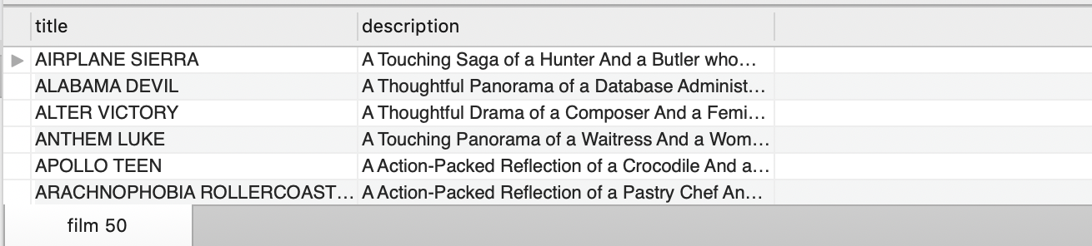

**# b) List all movies that are either PG OR PG-13 using IN operator ?**

SELECT

title, description

FROM

film

WHERE

rating IN ('PG' , 'PG-13');

417 row(s) returned

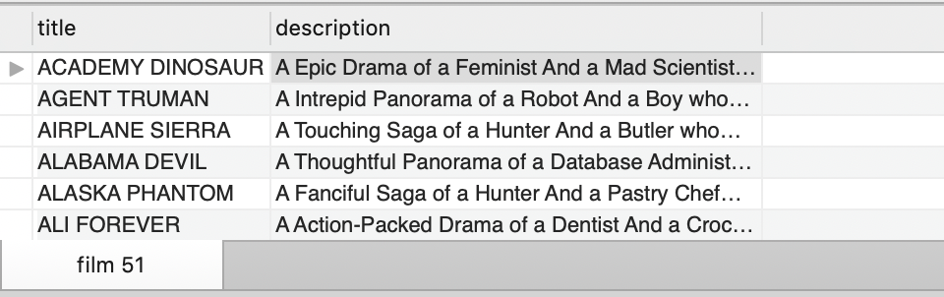

**# c) Report all payments greater than and equal to 2$ and Less than equal to 7$ ?**

**# Note : write 2 separate queries conditional operator and BETWEEN keyword**

SELECT

*

FROM

payment

WHERE

(amount >= 2

AND amount <= 7);

1000 row(s) returned

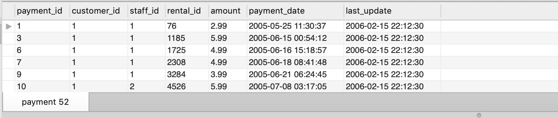

SELECT

*

FROM

payment

WHERE

buyPrice BETWEEN 2 AND 7;

1000 row(s) returned

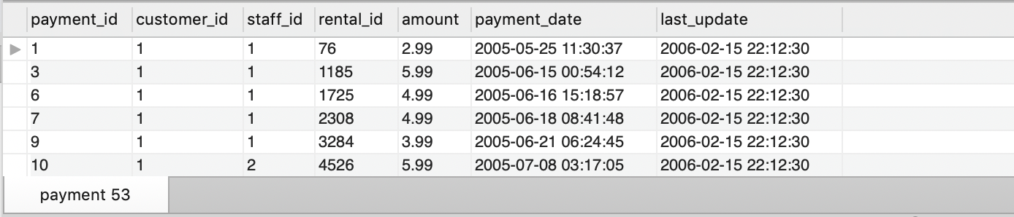

**# d) List all addresses that have phone number that contain digits 589, start with 140 or end with 589**

**# Note : write 3 different queries**

SELECT

*

FROM

address

WHERE

phone LIKE '%589%';

6 row(s) returned

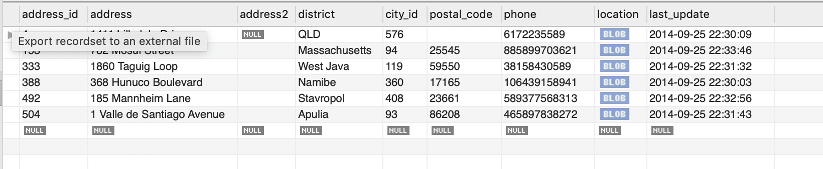

SELECT

*

FROM

address

WHERE

phone LIKE '140%';

1 row(s) returned

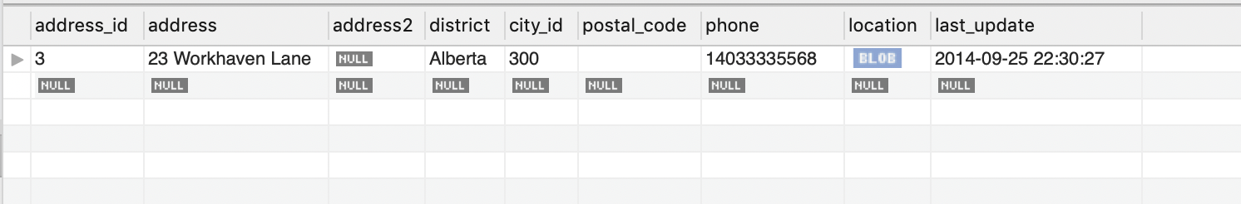

SELECT

*

FROM

address

WHERE

phone LIKE '%589';

2 row(s) returned

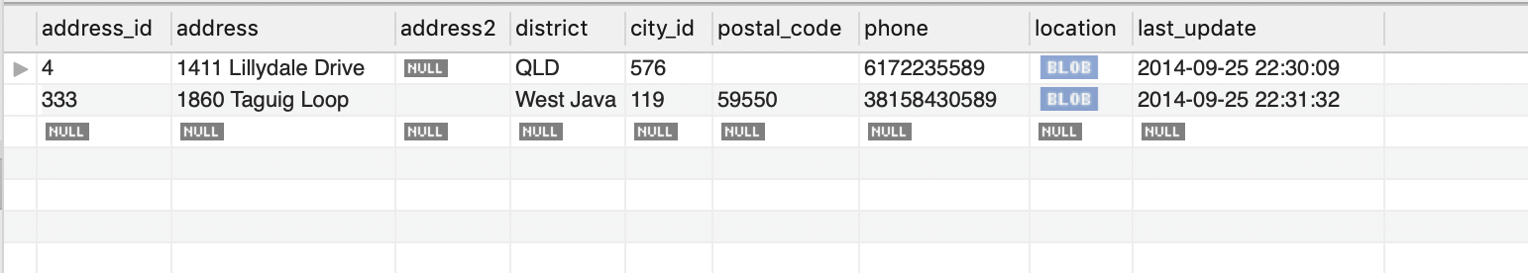

**# e) List all staff members ( first name, last name, email ) whose password is NULL ?**

SELECT DISTINCT

first_name, last_name, email

FROM

staff

WHERE

password IS NULL;

1 row(s) returned

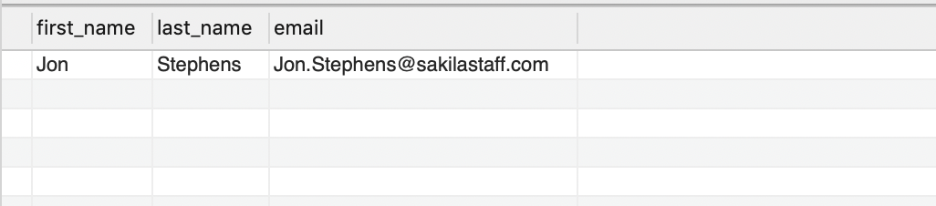

Returned result: Jon Stephens

**# f) Select all films that have title names like ZOO and rental duration greater than or equal to 4**

SELECT

*

FROM

film

WHERE

title LIKE '%ZOO%' AND

length >= 4;

4 row(s) returned

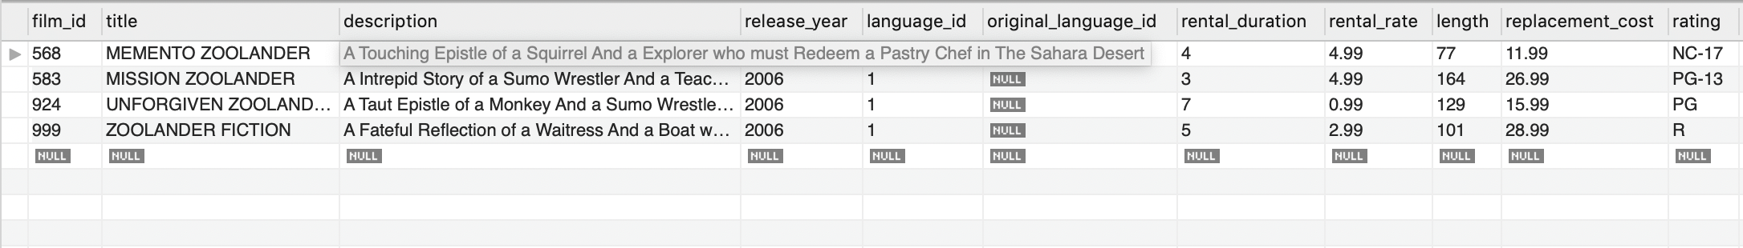

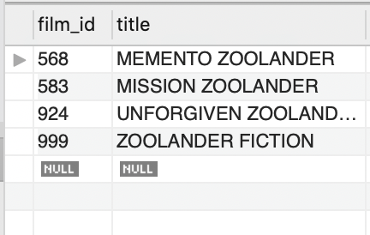

**# g) What is the cost of renting the movie ACADEMY DINOSAUR for 2 weeks ?**

**# Note : use of column alias**

SELECT

(rental_rate * 14) AS rentalCost

FROM

film

WHERE

title LIKE 'ACADEMY DINOSAUR';

1 row(s) returned

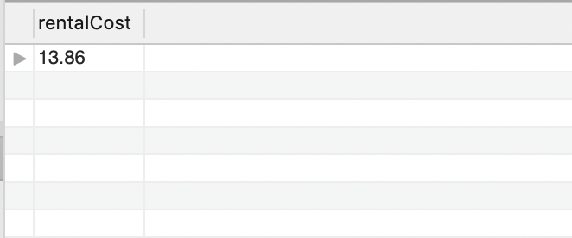

Returned value = 13.86 dollars

**# h) List all unique districts where the customers, staff, and stores are located**

**# Note : check for NOT NULL values**

SELECT DISTINCT

district

FROM

address

WHERE

district IS NOT NULL;

378 row(s) returned

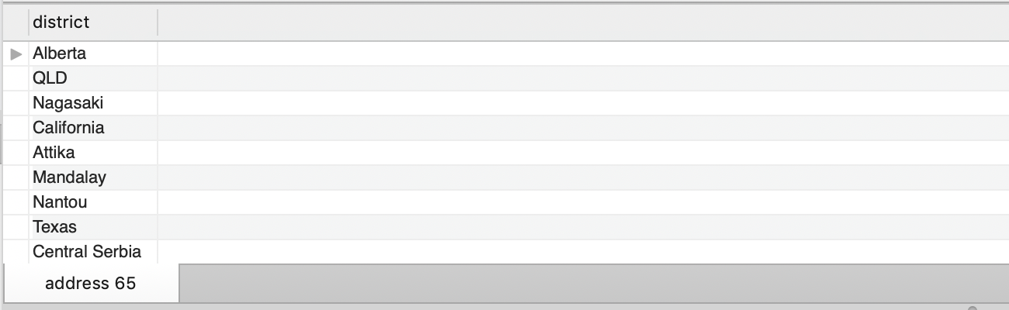

**# i) List the top 10 newest customers across all stores**

SELECT

*

FROM

customer

ORDER BY create_date DESC

LIMIT 10;

10 row(s) returned

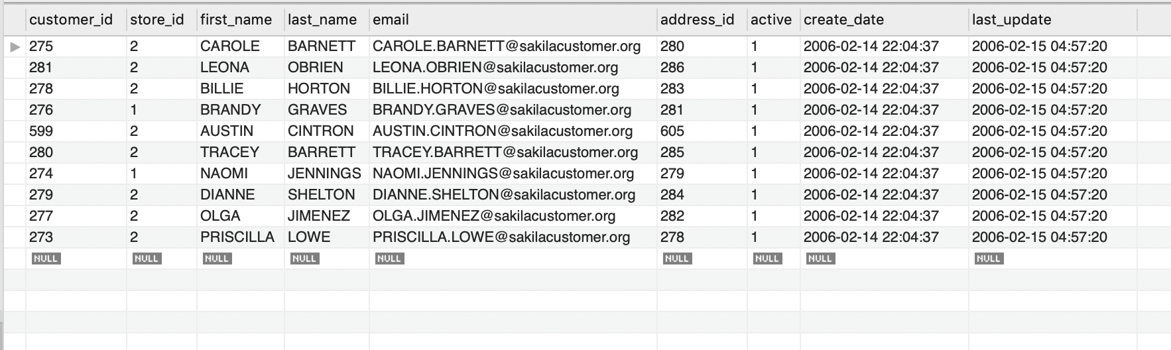

**######## QUESTION 3 ######## – { 10 Points }**

**# a) Show total number of movies**

SELECT

COUNT(film_id) AS numberOfMovies

FROM

film;

1 row(s) returned

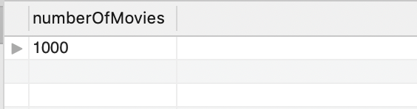

Returned 1,000 movies in total.

**# b) What is the minimum payment received and max payment received across all transactions ?**

SELECT

MAX(amount) as maxPayment

# MIN(amount) as minPayment

FROM

payment

1 row(s) returned

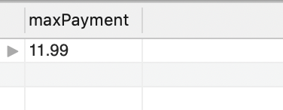

Returned 11.99 dollars

SELECT

# MAX(amount) as maxPayment

MIN(amount) as minPayment

FROM

payment

1 row(s) returned

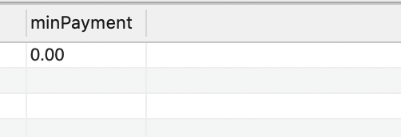

Returned 0 dollar.

**# c) Number of customers that rented movies between Feb-2005 & May-2005 ( based on** **paymentDate ).**

SELECT

COUNT(customer_id) AS totalCustomers

FROM

payment

WHERE

payment_date >= '2005-02-01'

AND payment_date <= '2005-05-31';

1 row(s) returned

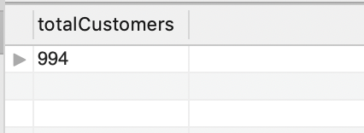

Returned 994 total customers.

**# d) List all movies where replacement_cost is greater than 15$ or rental_duration is between 6 & 10 days**

Select

title

FROM

film

WHERE

replacement_cost >= 15 AND

(rental_duration >= 6 AND rental_duration <= 10)

284 row(s) returned

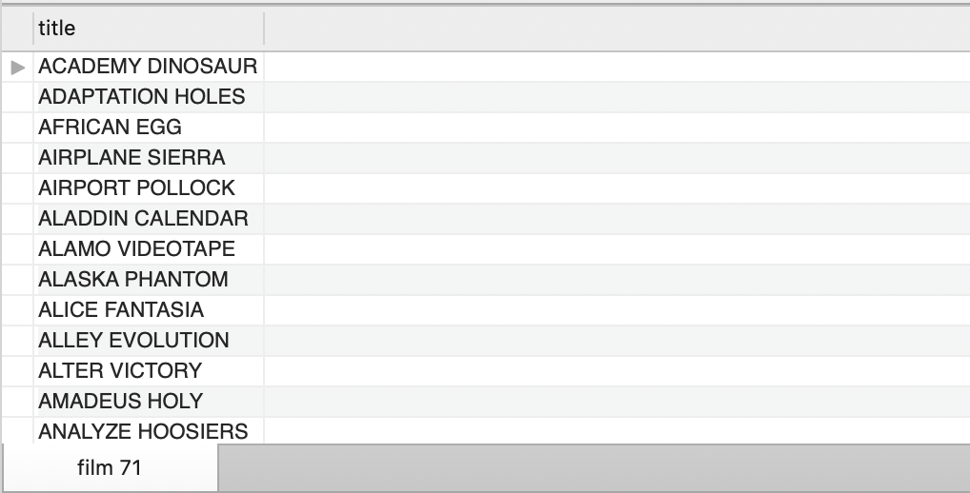

**# e) What is the total amount spent by customers for movies in the year 2005 ?**

SELECT

SUM(amount) AS totalAmountSpent

FROM

payment

WHERE

payment_date BETWEEN '2005-01-01' AND '2005-12-31';

1 row(s) returned

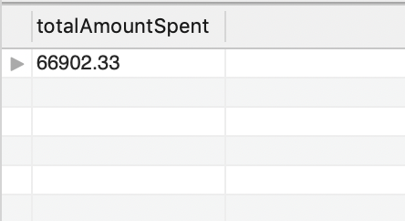

Returned 66902.33 dollars

**# f) What is the average replacement cost across all movies ?**

SELECT

SUM(replacement_cost) AS Total_replacement_cost

FROM

film;

1 row(s) returned

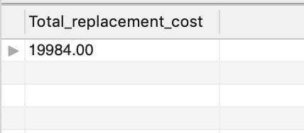

Returned 19,984 dollars.

**# g) What is the standard deviation of rental rate across all movies ?**

SELECT

STD(rental_rate) AS stdRental_rate

FROM

film;

1 row(s) returned

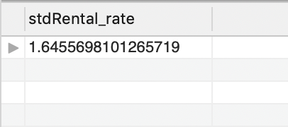

Returned 1.6456

**# h) What is the midrange of the rental duration for all movies**

SELECT

(MAX(rental_duration) + MIN(rental_duration)) / 2 AS midRange

FROM

film;

1 row(s) returned

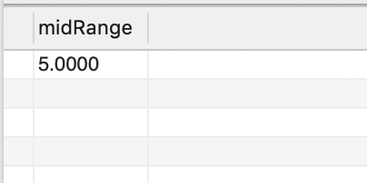

The middle ruange is 5.0000.

**######## QUESTION 4 ######## – { 10 Points }**

**# a) Customers sorted by first Name and last name in ascending order.**

SELECT

*

FROM

customer

ORDER BY first_name ASC, last_name ASC;

**# b) Count of movies that are either G/NC-17/PG-13/PG/R grouped by rating.**

SELECT

COUNT(film_id), rating

FROM

film

GROUP BY rating

**# c) Number of addresses in each district.**

SELECT

count(address), district

FROM address

GROUP BY district

378 row(s) returned

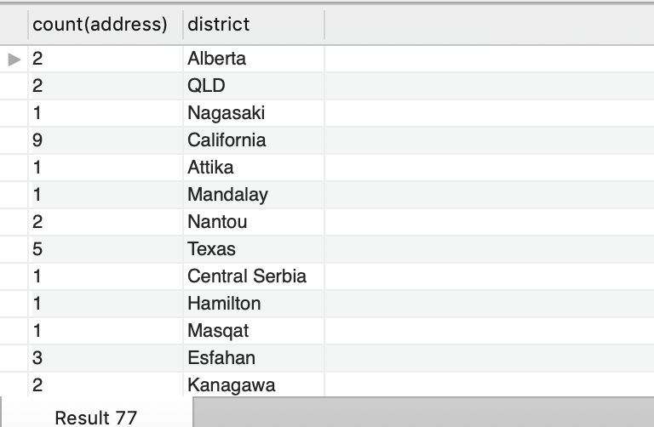

**# d) Find the movies where rental rate is greater than 1$ and order result set by descending order.**

SELECT DISTINCT

film_id, title, rental_rate

FROM

film

WHERE rental_rate > 1

ORDER BY rental_rate ASC;

659 row(s) returned

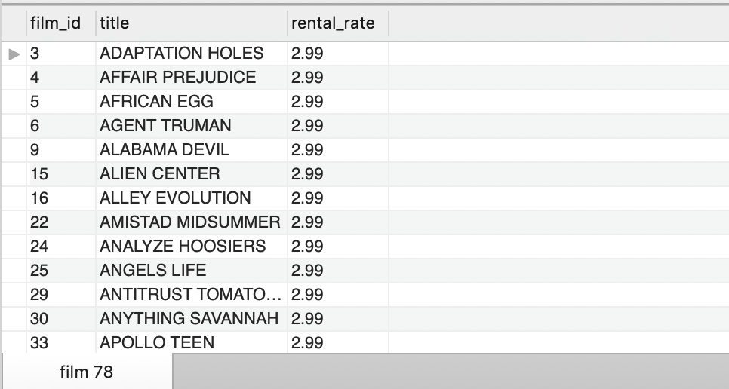

**# e) Top 2 movies that are rated R with the highest replacement cost ?**

SELECT DISTINCT

film_id, title, replacement_cost, rating

FROM

film

WHERE

rating = 'R'

ORDER BY replacement_cost DESC

LIMIT 2;

2 row(s) returned

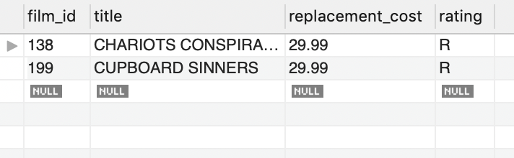

**# f) Find the most frequently occurring (mode) rental rate across products.**

SELECT

rental_rate, COUNT(rental_rate) AS RentalRateMode

FROM

film

ORDER BY RentalRateMode DESC

LIMIT 1;

1 row(s) returned

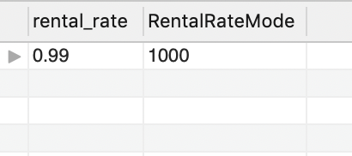

Returned 0.99 is the most frequently occurring rental rate.

**# g) Find the top 2 movies with movie length greater than 50mins and which has commentaries as a special features.**

SELECT DISTINCT

film_id, title, length, special_features

FROM

film

WHERE

length > 50

HAVING special_features LIKE '%commentaries%'

ORDER BY length DESC

LIMIT 2;

2 rows returned

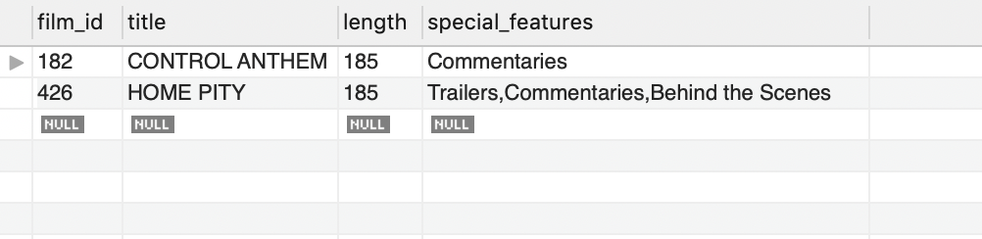

**# h) List the years which has more than 2 movies released.**

SELECT release_year, COUNT(DISTINCT(film_id)) as numberOfFilms

FROM film

GROUP BY release_year

HAVING COUNT(film_id) > 2;

1 row returned

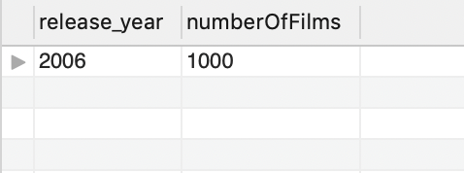

Returned year 2006.

**/***********************************************  
** File: Assignment2-PartC.sql  
** Desc: Combining Data, Nested Queries, Views and Indexes, Transforming Data**

**\*\* Author: Troy Zhongyi Zhang  
** Date: 07/26/2019  
************************************************/**

**######## QUESTION 1 ######## – { 20 Points }**

**# a) List the actors (firstName, lastName) who acted in more then 25 movies.**

**# Note: Also show the count of movies against each actor**

SELECT

a.first_name,

a.last_name,

COUNT(DISTINCT f.film_id) AS TotalNumberOfMovies

FROM

film_actor f

INNER JOIN

actor a USING (actor_id)

GROUP BY a.actor_id

HAVING totalNumberOfMovies > 25

ORDER BY a.actor_id;

125 row(s) returned

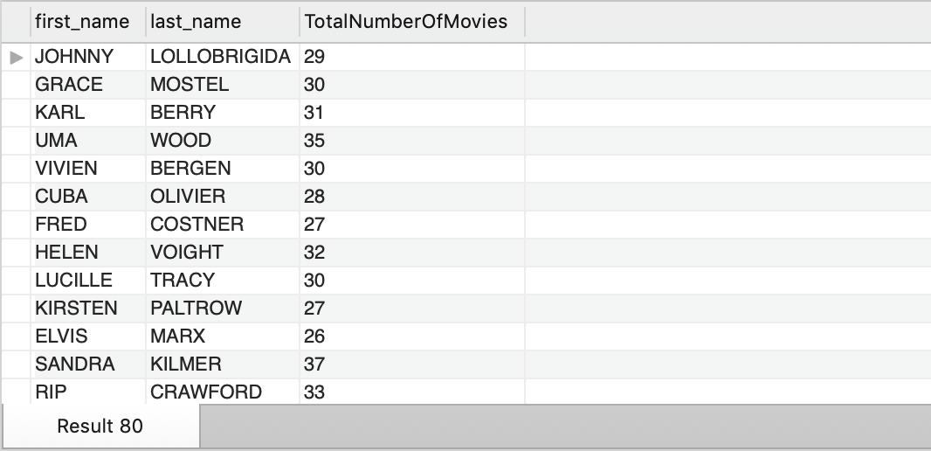

**# b) List the actors who have worked in the German language movies.**

**# Note: Please execute the below SQL before answering this question.  
SET SQL_SAFE_UPDATES=0;  
UPDATE film SET language_id=6 WHERE title LIKE "%ACADEMY%";**

SET SQL_SAFE_UPDATES=0;

UPDATE film SET language_id=6 WHERE title LIKE "%ACADEMY%";

SELECT

l.language_id, l.name, a.actor_id, a.first_name, a.last_name

FROM

language l

INNER JOIN

film f ON l.language_id = f.language_id

INNER JOIN

film_actor fa ON f.film_id = fa.film_id

INNER JOIN

actor a ON fa.actor_id = a.actor_id

WHERE

l.language_id = 6;

2 row(s) affected Rows matched: 2 Changed: 2 Warnings: 0

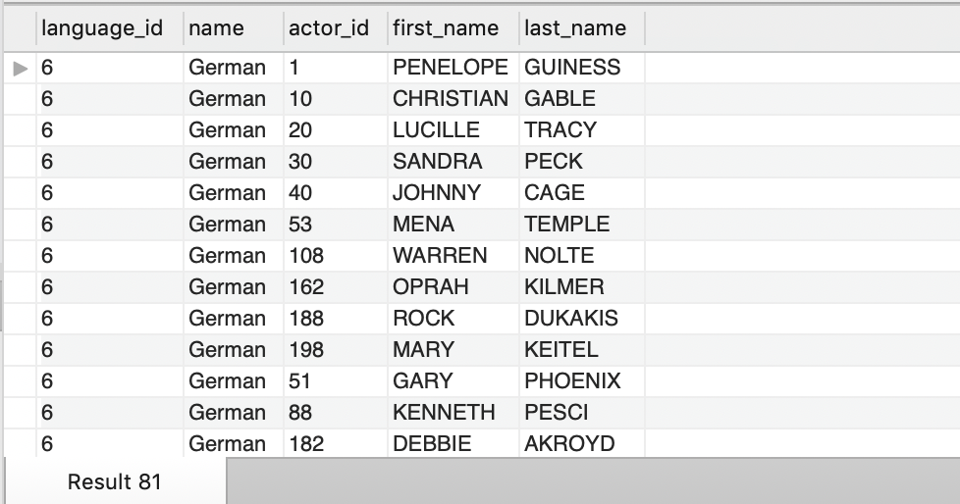

**# c) List the actors who acted in horror movies.  
# Note: Show the count of movies against each actor in the result set.**

SELECT c.name, a.first_name, a.last_name, COUNT(f.film_id)

FROM actor a

INNER JOIN film_actor fa

ON a.actor_id = fa.actor_id

LEFT JOIN film f

ON fa.film_id = f.film_id

LEFT JOIN film_category fc

ON f.film_id = fc.film_id

LEFT JOIN category c

ON fc.category_id = c.category_id

WHERE c.name = 'horror'

GROUP BY a.first_name, a.last_name;

155 row(s) returned

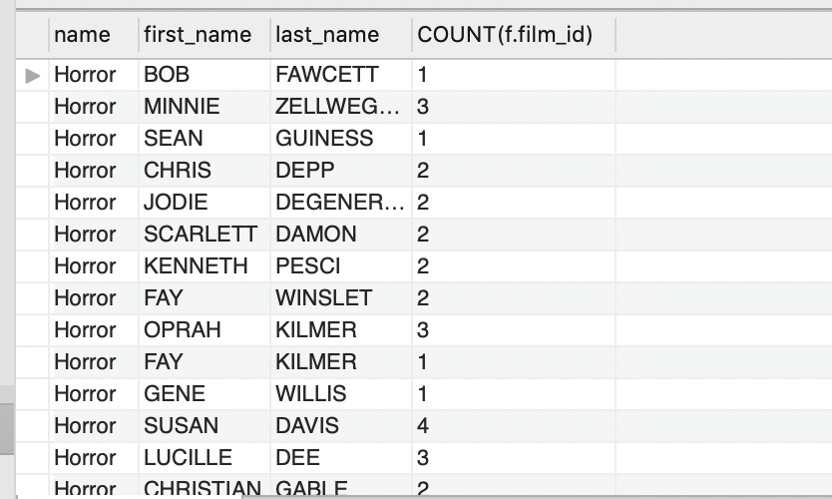

**# d) List all customers who rented more than 3 horror movies.**

SELECT

c.customer_id,

c.first_name,

c.last_name,

COUNT(fc.film_id) AS NumberOfHorrorMovies,

a.first_name,

a.last_name

FROM

customer c

INNER JOIN

rental r ON c.customer_id = r.customer_id

INNER JOIN

inventory i ON i.inventory_id = r.inventory_id

INNER JOIN

film_category fc ON fc.film_id = i.film_id

INNER JOIN

category ca ON ca.category_id = fc.category_id

INNER JOIN

film_actor fa ON fc.film_id = fa.film_id

INNER JOIN

actor a ON fa.actor_id = a.actor_id

WHERE

ca.name = 'Horror'

GROUP BY c.customer_id

HAVING NumberOfHorrorMovies > 3;

429 row(s) returned

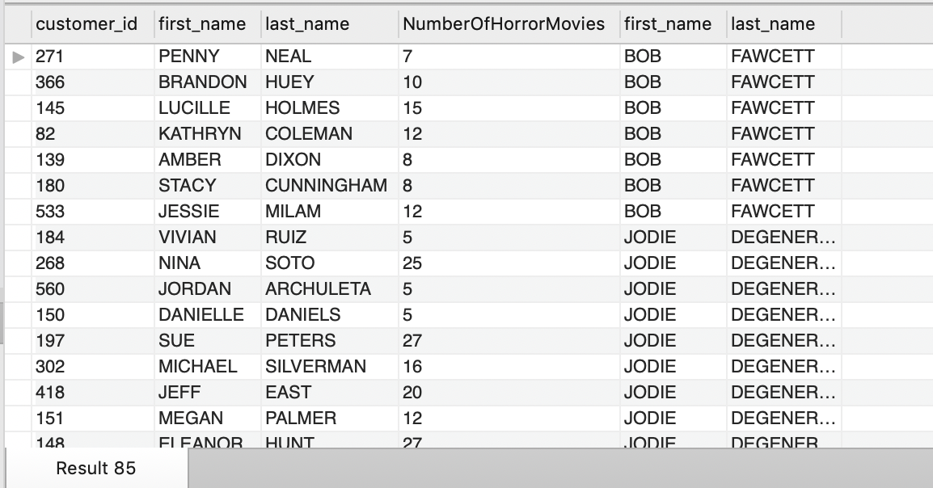

**# e) List all customers who rented the movie which starred SCARLETT BENING**

SELECT DISTINCT

c.customer_id,

c.first_name,

c.last_name,

fa.film_id,

a.first_name,

a.last_name

FROM

customer c

INNER JOIN

rental r ON c.customer_id = r.customer_id

INNER JOIN

inventory i ON i.inventory_id = r.inventory_id

INNER JOIN

film_actor fa ON fa.film_id = i.film_id

INNER JOIN

actor a ON a.actor_id = fa.actor_id

WHERE

a.first_name = 'SCARLETT'

AND a.last_name = 'BENING';

356 row(s) returned

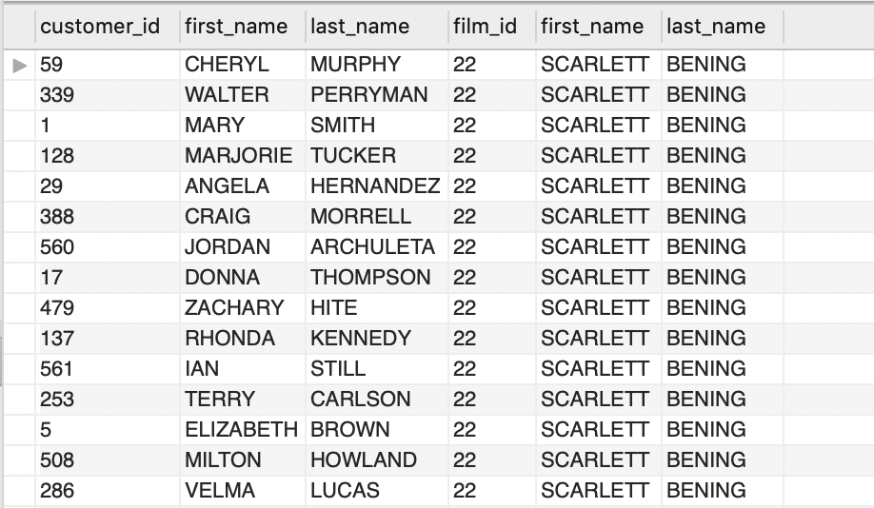

**# f) Which customers residing at postal code 62703 rented movies that were Documentaries.**

SELECT

c.customer_id,

c.first_name,

c.last_name,

a.address,

a.address2,

a.postal_code,

ca.name

FROM

customer c

INNER JOIN

rental r ON c.customer_id = r.customer_id

INNER JOIN

inventory i ON i.inventory_id = r.inventory_id

INNER JOIN

film_category fc ON fc.film_id = i.film_id

INNER JOIN

category ca ON ca.category_id = fc.category_id

INNER JOIN

address a ON a.address_id = c.address_id

WHERE

ca.name = 'Documentary'

AND a.postal_code = '62703';

1 row(s) returned

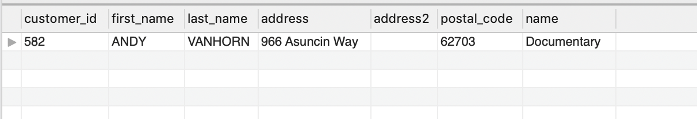

**# g) Find all the addresses where the second address line is not empty (i.e., contains some text), and return these second addresses sorted.**

SELECT

address, address2

FROM

address

WHERE

TRIM(address2) IS NOT NULL

ORDER BY address2;

599 row(s) returned

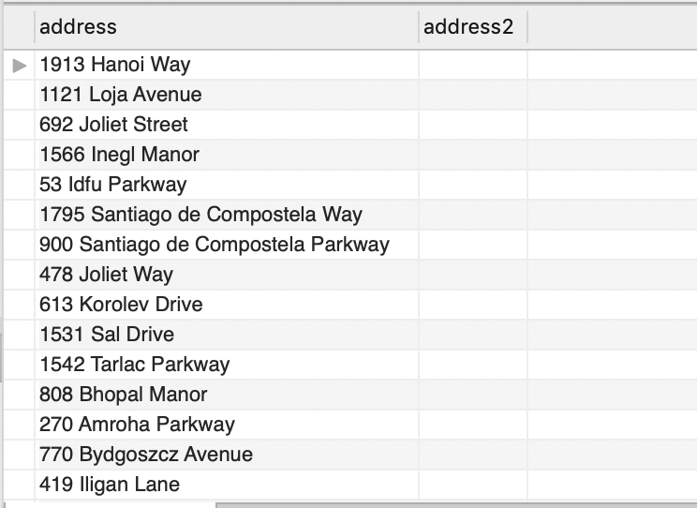

**# h) How many films involve a “Crocodile” and a “Shark” based on film description ?**

SELECT COUNT(film_id) as numberOfFilms

FROM film

WHERE description LIKE '%Crocodile%' AND description LIKE '%Shark%';

1 row(s) returned

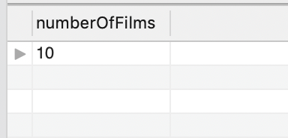

Returned total number of 10 films.

**# i) List the actors who played in a film involving a “Crocodile” and a “Shark”, along with the release year of the movie, sorted by the actors’ last names.**

SELECT DISTINCT

a.first_name,

a.last_name,

f.title,

f.description,

f.release_year

FROM

film f

INNER JOIN

film_actor fa ON f.film_id = fa.film_id

INNER JOIN

actor a ON a.actor_id = fa.actor_id

WHERE

description LIKE '%Crocodile%'

AND description LIKE '%Shark%'

ORDER BY a.last_name;

58 row(s) returned

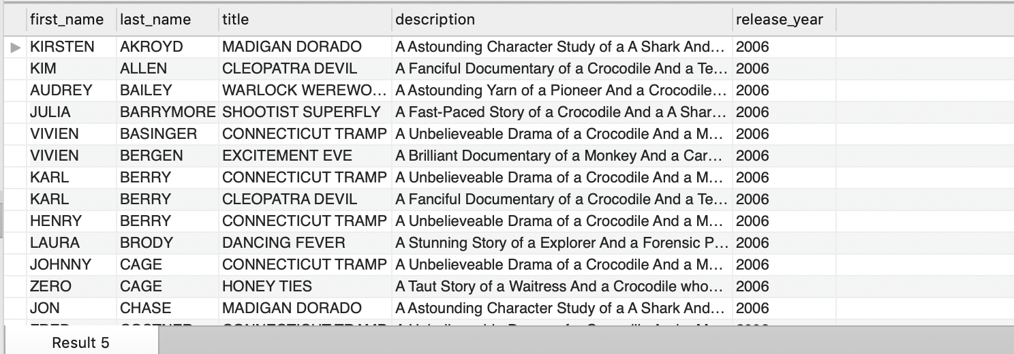

**# j) Find all the film categories in which there are between 55 and 65 films. Return the names of categories and the number of films per category, sorted from highest to lowest by the number of films.**

SELECT c.name, COUNT(fc.film_id) AS num_films

FROM film_category fc

LEFT JOIN category c

ON fc.category_id = c.category_id

GROUP BY c.name

HAVING COUNT(fc.film_id) BETWEEN 55 AND 65

ORDER BY COUNT(fc.film_id) DESC;

10 row(s) returned

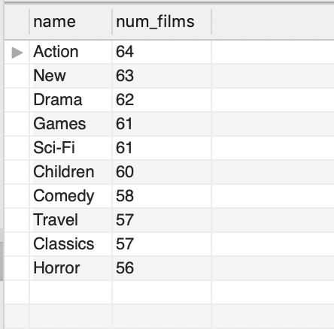

**# k) In which of the film categories is the average difference between the film replacement cost and the rental rate larger than 17$?**

SELECT

c.name,

AVG(f.replacement_cost) AS avgReplacementCost,

AVG(f.rental_rate) AS avgRentalRate,

ABS(AVG(f.replacement_cost) - AVG(f.rental_rate)) AS avgDifference

FROM

category c

INNER JOIN

film_category fc ON c.category_id = fc.category_id

INNER JOIN

film f ON f.film_id = fc.film_id

GROUP BY c.name

HAVING avgDifference > 17;

8 row(s) returned

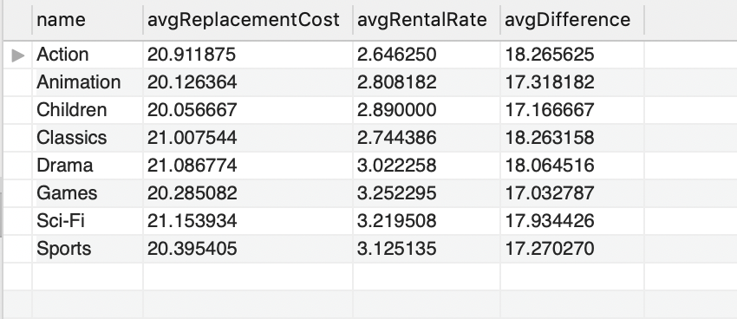

**# l) Many DVD stores produce a daily list of overdue rentals so that customers can be contacted and asked to return their overdue DVDs. To create such a list, search the rental table for films with a return date that is NULL and where the rental date is further in the past than the rental duration specified in the film table. If so, the film is overdue and we should produce the name of the film along with the customer name and phone number.**

SELECT

c.first_name,

c.last_name,

ad.phone,

f.title,

r.rental_date,

r.return_date,

f.rental_duration,

DATEDIFF(r.return_date, r.rental_date) AS actualrentalduration

FROM

customer c

LEFT JOIN

rental r ON r.customer_id = c.customer_id

LEFT JOIN

address ad ON c.address_id = ad.address_id

LEFT JOIN

inventory i ON i.inventory_id = r.inventory_id

LEFT JOIN

film f ON f.film_id = i.film_id

WHERE

DATEDIFF(r.return_date, r.rental_date) > f.rental_duration

OR r.return_date IS NULL;

1000 row(s) returned

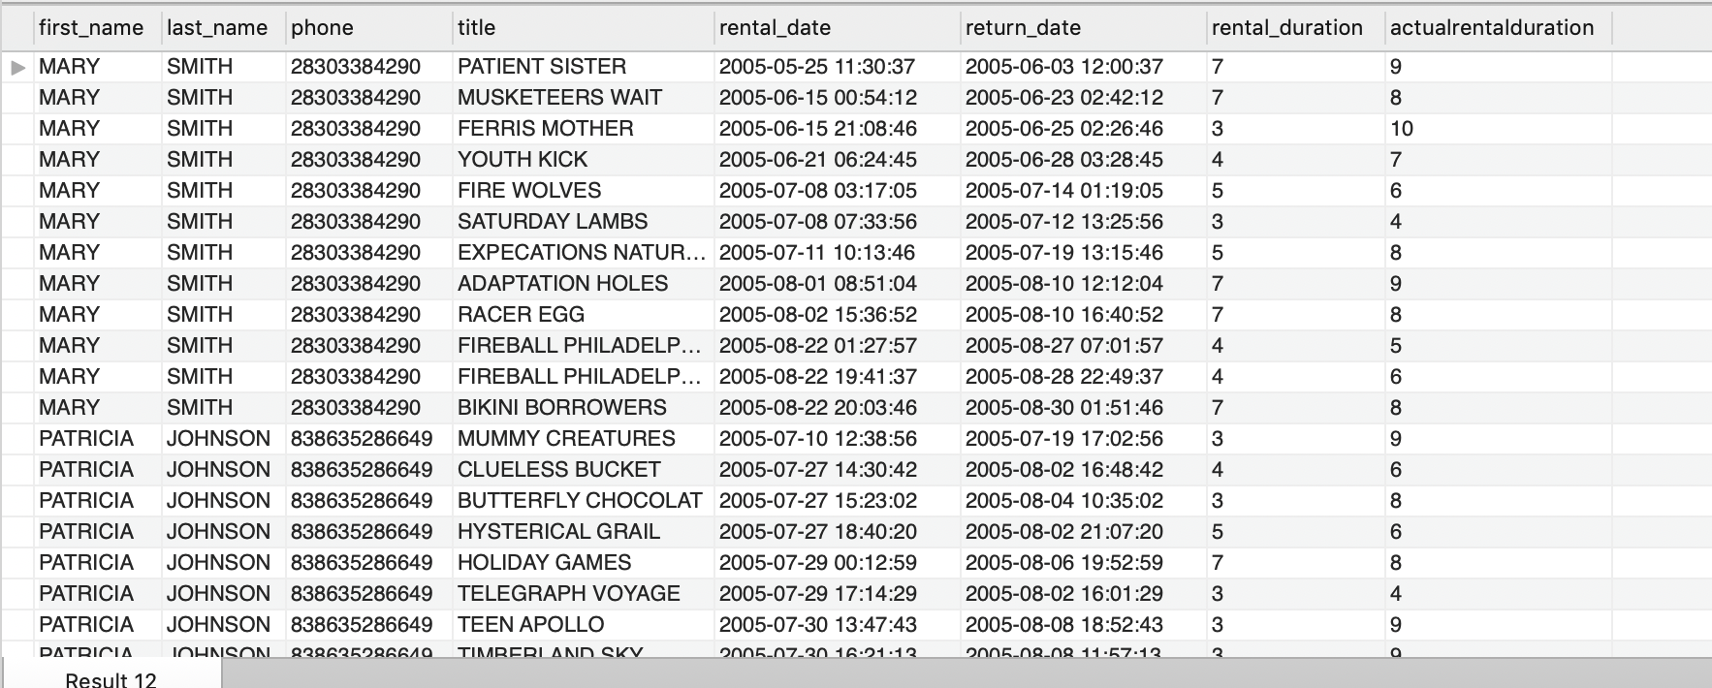

**# m) Find the list of all customers and staff given a store id**

**# Note : use a set operator, do not remove duplicates**

SELECT store_id, first_name, last_name

FROM customer

UNION ALL

SELECT store_id, first_name, last_name

FROM staff

ORDER BY store_id;

601 row(s) returned

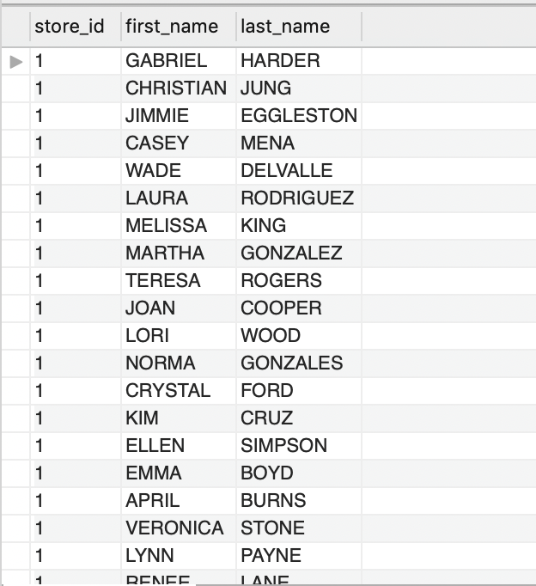

**######## QUESTION 2 ######## – { 10 Points }**

**# a) List actors and customers whose first name is the same as the first name of the actor with ID 8.**

SHOW all the actors and customers’ first name, which are same as the first name of the actor with ID 8:

SELECT a.actor_id, a.first_name AS actfirst, a.last_name AS actlast, cusfirstname, cuslastname

FROM actor a

JOIN

(SELECT first_name AS cusfirstname, last_name AS cuslastname

FROM customer

WHERE first_name = (SELECT first_name

FROM actor

WHERE actor_id = 8)) AS t1

ON a.first_name = t1.cusfirstname;

3 row(s) returned

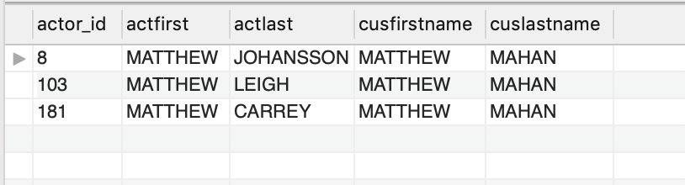

If only return the customer’s first name, which are same as the first name of the actor with ID8:

SELECT

a.actor_id,

a.first_name AS actorFirstName,

a.last_name AS actorLastName,

c.first_name AS customerFirstName,

c.last_name AS customerLastName

FROM

actor AS a, customer AS c

WHERE

a.first_name = c.first_name AND a.actor_id = 8;

1 row(s) returned

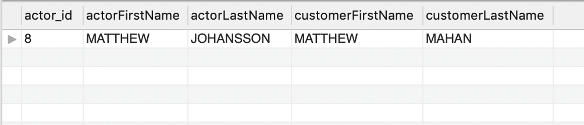

**# b) List customers and payment amounts, with payments greater than average the payment amount**

SELECT

c.customer_id, c.first_name, c.last_name, p.amount

FROM

customer c,

payment p

WHERE

p.amount > (SELECT

AVG(amount)

FROM

payment);

1000 row(s) returned

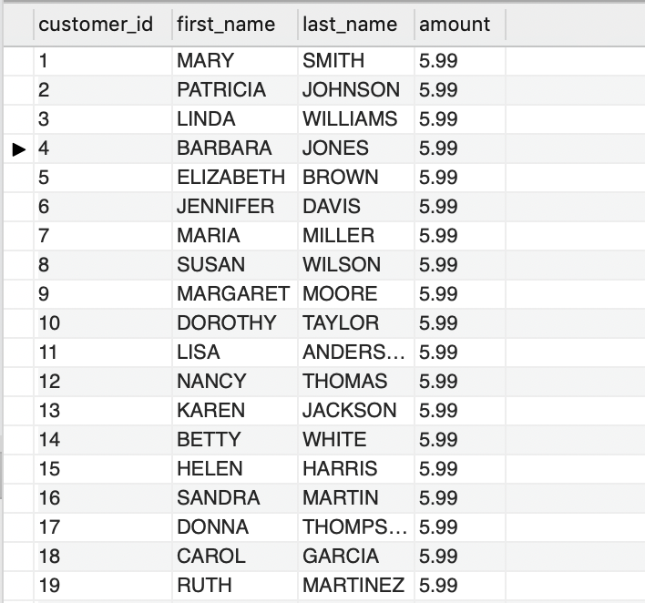

**# c) List customers who have rented movies at least once**

**# Note: use IN clause**

SELECT customer_id, first_name, last_name

FROM customer

WHERE customer_id IN (SELECT DISTINCT customer_id FROM rental);

599 row(s) returned

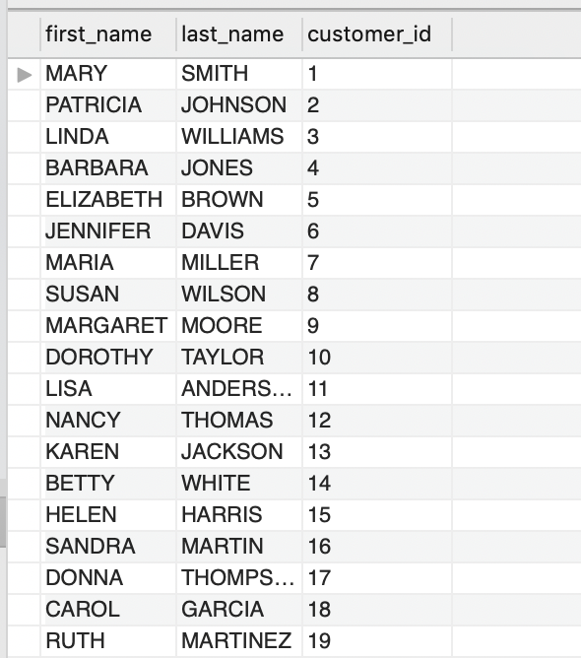

**# d) Find the floor of the maximum, minimum and average payment amount**

SELECT MAX(amount), MIN(amount), AVG(amount)

FROM payment;

1 row(s) returned

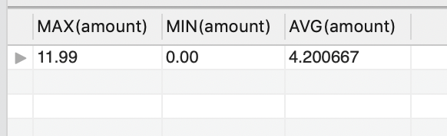

**######## QUESTION 3 ######## – { 5 Points }**

**# a) Create a view called actors_portfolio which contains information about actors and films ( including titles and category).**

DROP VIEW IF EXISTS actors_portfolio;

CREATE VIEW actors_portfolio AS

SELECT

a.actor_id,

a.first_name,

a.last_name,

f.film_id,

f.title,

f.description,

f.release_year,

f.language_id,

f.original_language_id,

f.rental_duration,

f.rental_rate,

f.length,

f.replacement_cost,

f.rating,

f.special_features,

c.name AS category_name

FROM

actor a

LEFT JOIN

film_actor fa ON a.actor_id = fa.actor_id

LEFT JOIN

film f ON f.film_id = fa.film_id

LEFT JOIN

film_category fc ON fc.film_id = f.film_id

LEFT JOIN

category c ON c.category_id = fc.category_id;

0 row(s) affected

**# b) Describe the structure of the view and query the view to get information on the actor ADAM GRANT**

DESCRIBE actors_portfolio;

SELECT

*

FROM

actors_portfolio

WHERE

first_name = 'ADAM'

AND last_name = 'GRANT';

18 row(s) returned

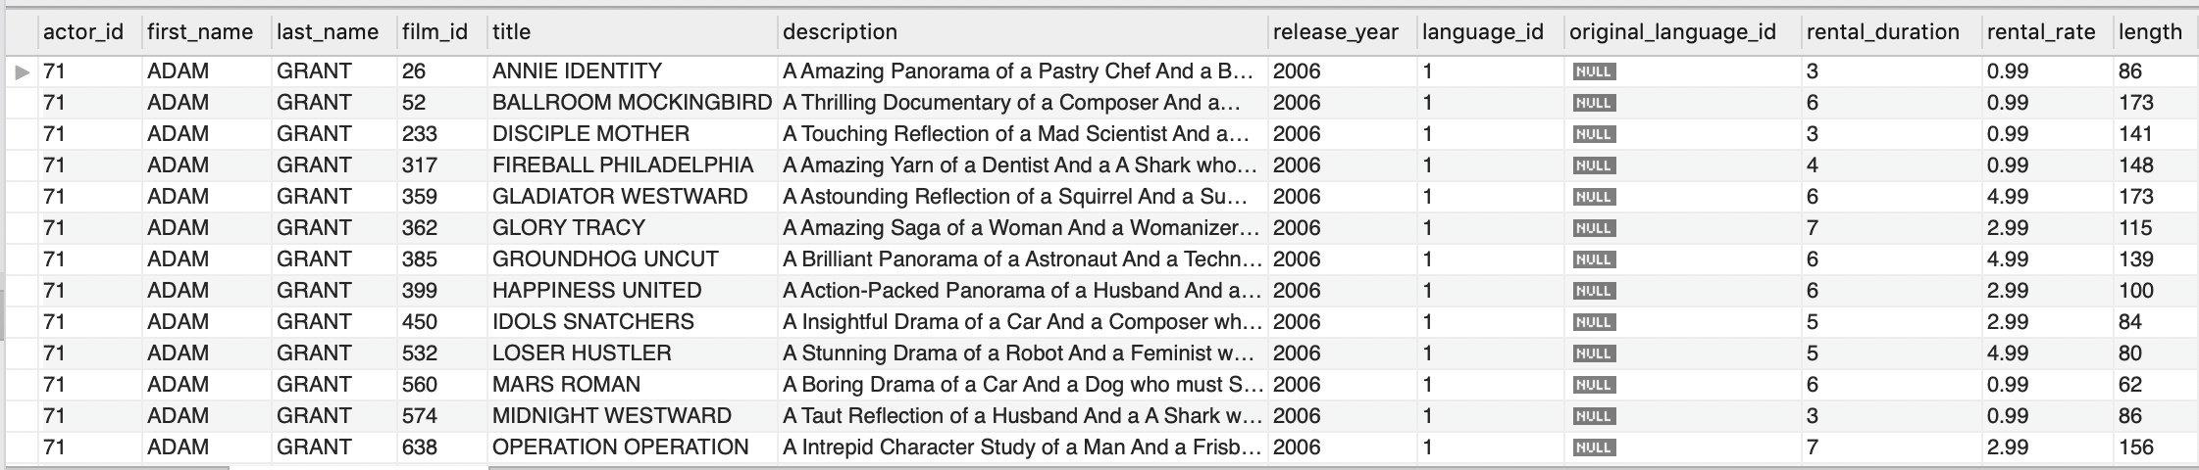

**# c) Insert a new movie titled Data Hero in Sci-Fi Category starring ADAM GRANT**

INSERT INTO actors_portfolio (actor, title, category)

VALUES('ADAM GRANT','Data Hero','Sci-Fi');

1 row(s) affected

**######## QUESTION 4 ######## – { 5 Points }**

**# a) Extract the street number ( characters 1 through 4 ) from customer addressLine1**

SELECT

c.first_name,

c.last_name,

SUBSTRING(address, 1, 4) AS streetNumber

FROM

customer AS c

INNER JOIN

address USING (address_id);

599 row(s) returned

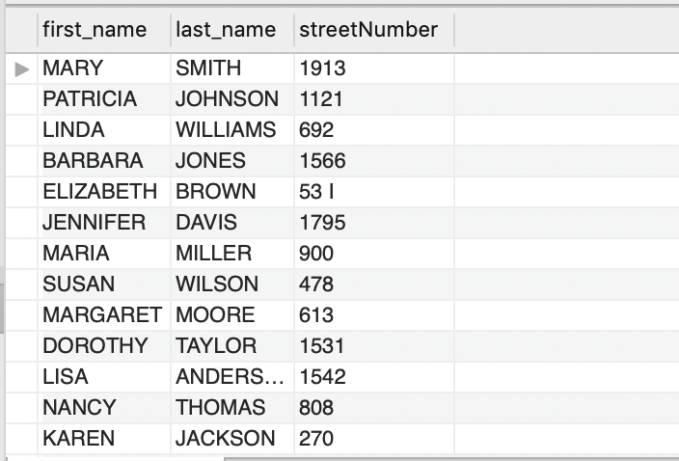

**# b) Find out actors whose last name starts with character A, B or C.**

SELECT *

FROM actor

WHERE last_name LIKE 'A%' OR last_name LIKE 'B%' OR last_name LIKE 'C%';

44 row(s) returned

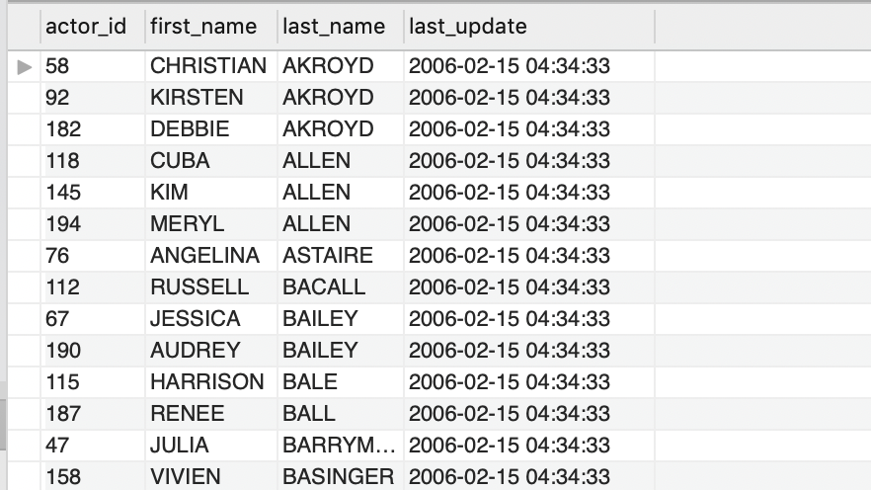

**# c) Find film titles that contains exactly 10 characters**

SELECT title

FROM film

WHERE title REGEXP '^.{10}$';

**Or**

SELECT title

FROM film

WHERE CHAR_LENGTH(title) = 10;

Both queries ways give

66 row(s) returned



**# d) Format a payment_date using the following format e.g "22/1/2016"**

SELECT DATE_FORMAT(payment_date, '%d-%m-%Y') AS Newformat

FROM payment;

1000 row(s) returned

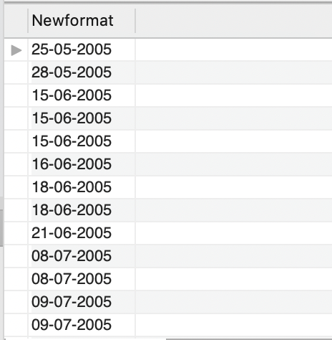

**# e) Find the number of days between two date values rental_date & return_date ‘**

SELECT DATEDIFF(return_date, rental_date) AS numberOfDays

FROM rental;

1000 row(s) returned

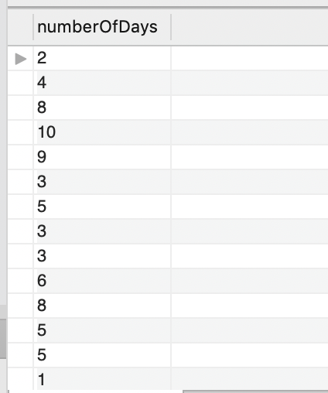

**######## QUESTION 5 ######## – { 20 Points }**

**# Provide 5 additional queries and indicate the specific business use cases they address.**

1. **Which movie has been rented the most in these several years? Which film could potentially bring more benefits and profits? It could help business to obtain the information on which movie category is the most potentially popular.**

SELECT EXTRACT(year FROM r.rental_date) AS whichYear, c.name AS categoryNAME, COUNT(*) AS num

FROM rental r

INNER JOIN inventory i

ON r.inventory_id = i.inventory_id

INNER JOIN film f

ON i.film_id = f.film_id

INNER JOIN film_category fc

ON f.film_id = fc.film_id

INNER JOIN category c

ON fc.category_id = c.category_id

GROUP BY 1,2

ORDER BY 1, 3 DESC;

32 row(s) returned

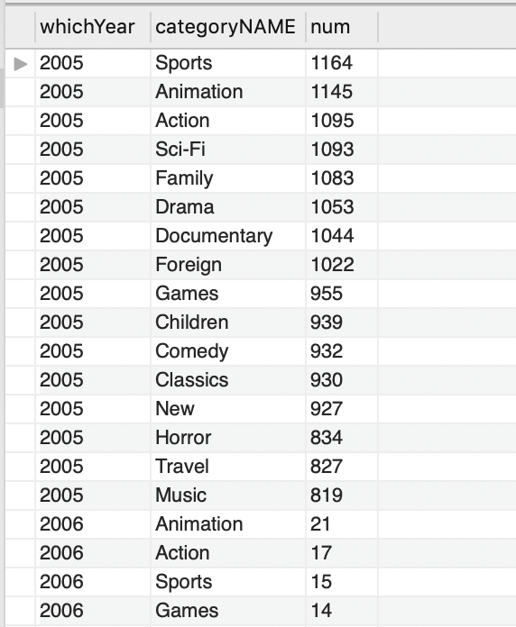

1. **Which actors are the most popular actors on market in the recent years? It could help business to potentially evaluate the value of an actor.**

SELECT CONCAT(a.first_name,' ',a.last_name) AS actor, COUNT(f.film_id) AS numofFilms

FROM actor a

INNER JOIN film_actor fa

ON a.actor_id = fa.actor_id

LEFT JOIN film f

ON fa.film_id = f.film_id

GROUP BY 1

ORDER BY 2 DESC;

199 row(s) returned

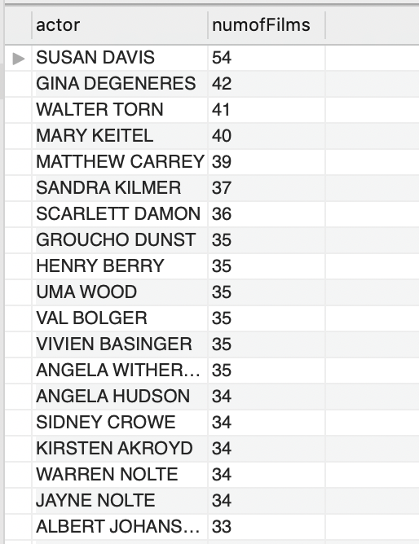

1. **Help business to obtain the information for staff and customers’ name if the customer and staff have the same address id.**

SELECT

c.first_name as cust_first, c.last_name as cust_last,

s.store_id as staff_first, s.last_name as staff_last

FROM

customer c

INNER JOIN

staff s

WHERE c.address_id = s.address_id

0 row(s) returned

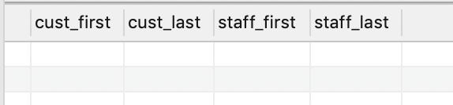

1. **Help business to obtain the information on which staff process the specific payment. Sort by payment amount in descending order.**

SELECT CONCAT(s.first_name,' ',s.last_name) AS staff, p.amount, p.payment_id, s.email, s.last_update

FROM staff s INNER JOIN payment p

WHERE p.amount >= 1

ORDER BY amount desc

LIMIT 100

100 row(s) returned

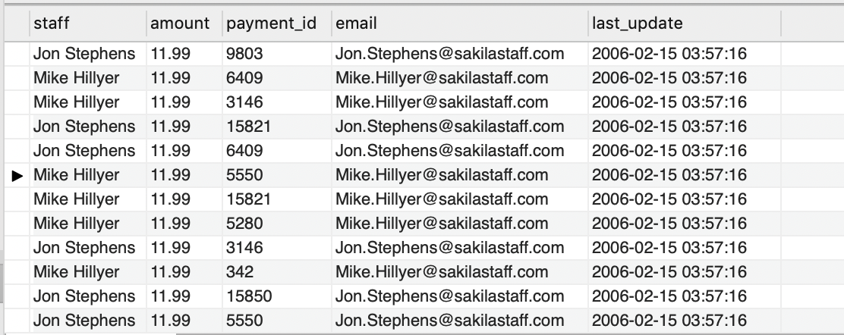

1. **Help business to obtain the information on how many movies in each language within every category of the movie.**

SELECT c.name, l.name, COUNT(l.language_id) AS numberOfMovies

FROM

language l LEFT JOIN film f ON l.language_id = f.language_id

LEFT JOIN film_category fc ON f.film_id = fc.film_id

LEFT JOIN category c ON fc.category_id = c.category_id

GROUP BY 1,2

21 row(s) returned

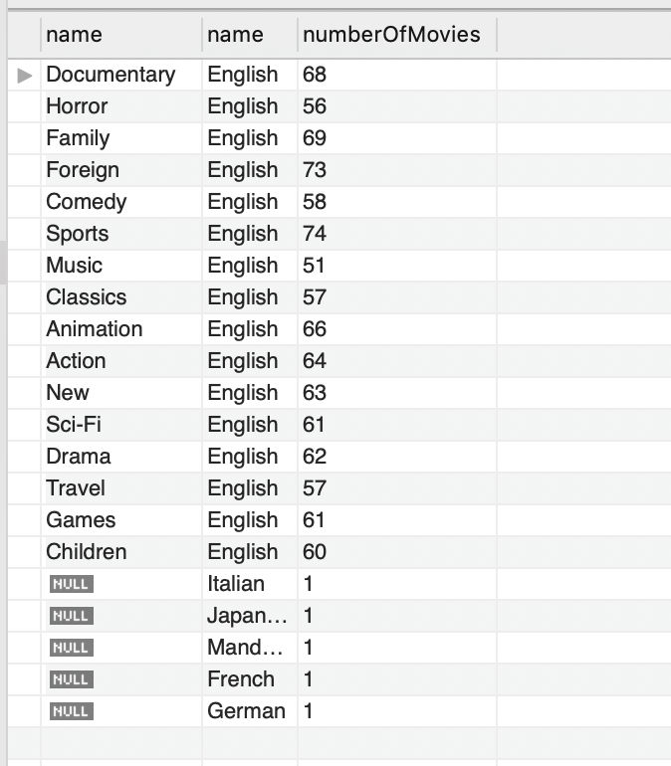

This Sakila data set collects most of the movies in English, so the resulting language is mostly English. However, as the data set gets larger or for some other business use cases, this query will still be beneficial to visualize the data and give some insights to the business.